KEY CONCEPTS | YEARS F-2 | YEARS 3-4 | YEARS 5-6
Representing data  Managing and analysing data | Recognise and explore patterns in data and represent data as pictures, symbols and diagrams (ACTDIK002)  Collect, explore and sort data, and use digital systems to present the data creatively (ACTDIP003) | Collect, access and present different types of data using simple software to create information and solve problems (ACTDIP009)  Recognise different types of data and explore how the same data can be represented in different ways (ACTDIK008) | Acquire, store and validate different types of data, and use a range of software to interpret and visualise data to create information (ACTDIP016)  using digital systems to validate data, for example setting data types in a spreadsheet to make sure a date is input correctly
 | Foundation Data: Collect, and sort data through play, for example collecting data about favourite toys and sorting them into categories such as toys they like or dislike.  Foundation & Y1 Patterns in Data: Experiment with different ways of representing patterns, for example using materials or drawing.  Y1 Data: Explore, imagine and compare the usefulness of different data displays, for example jointly creating simple column graphs and picture graphs to represent different types of items.  Y2 Data: Begin by brainstorming why do we collect data? What topics would be interesting to know about your classmates? Students can pick one topic and collect data about it from classmates. Students represent the data (e.g. maybe in a picture format, graph on the computer).  Make generalisations about data sets, for example comparing different ways of travelling to and from school using classroom data, discussing results and finding patterns in modes of travel.  Use digital systems to organise data to improve meaning, for example using Microsoft word processing software to create a list of tasks.  Explore symbols that represent data. For example, an email address has a name followed by an @ symbol followed by type of name. | Y3 Data: Sync device to OneDive. Explore how data can be represented in different ways. Create folders using OneDrive desktop icon, save different types of data (text, images and audio) into files. Customise icons on desktop, start menu and task bar. Access MineCraft world (%appdata%), copy and save a back up copy to OneDrive.  Y3 Excel: Use Microsoft Excel to explore cell, columns and rows. Create simple spreadsheet of data (ie Class’s favourite colour) and then generate column graph. Improve the appearance and usability of data, for example using colour, headings and labelling of images to organise and accurately identify data.  Y4 Microsoft Excel: Sort numerical and categorical data in ascending or descending order and automate simple arithmetic calculations using nearby cells and summing cell ranges in spreadsheet or database software.  Y4 Data Storage: Students explore different forms of data storage, from USB, to external hard drive, to school network to Web (One Drive).  Y4 Image Data: Use creative common sites to access and download data (Pixabay , Pics4Learning ) and .jpg and .png. Compare size, email as both and compare time taken to open each.  Examine an image of a favourite children’s animal or character (or related to teacher unit theme). Zoom in at various stages (or print versions of enlarged images to the point of pixilation). Discuss what the children see (that the image is made up of lots of little square blocks of colour). Look at early computer game images (e.g. Mario). Students could colour in graph paper to form their own images.  Develop students understand how images are compressed. Unplugged compression activity could be done with students. Have students make and decipher their each others’ images on grid paper.  . | Y5 Data Collection: Use Microsoft Office 365 forms to generate surveys and collect data. Integrate with math unit.  Y5 Ethical use and storage of data:  Click View resource (video and PDF)  Y5 Sound Data: Explore sound data and how computers transfer sound. Record students’ voices using Audacity and have students represent the image as Pop Art using audacity and BeFunky. Compare names and discuss similarities and differences (shape, file size, length).  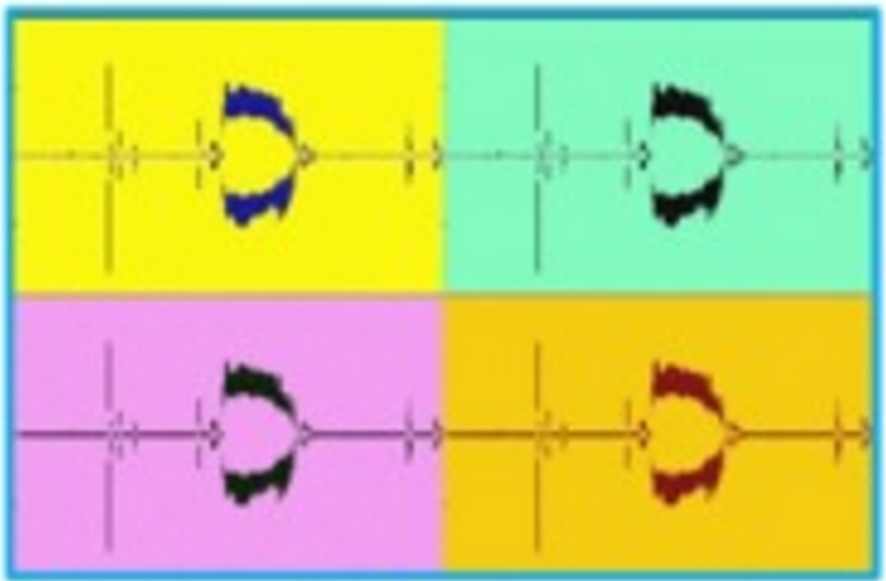  Integrate unit of work with Media Arts (Develop skills with media technologies to shape space, time, movement and lighting within images, sounds and text (ACAMAM063)​ ). Students create a community based radio segment by recording voice and inserting sound effects.  - Y5 and Y 6 Microsoft Excel: Recognise the difference between numerical, text and date formats in spreadsheets (LINK). Use Excel to automate calculations to help with interpreting data, for example using functions to make arithmetic calculations using multiple cells and summing cell ranges. Integrate this with Financial Maths.  Y6 Managing Data (Malware):  Students watch BTN clip on Cyber crime. They then need to copy the personal devices chart into their books and record their personal usage.  Students receive some information about viruses and watch a google presentation video about Malware. After the video, divide your class into 6 expert groups and they will create a fact file on a particular virus and then share with the rest of the class. Everyone will record the facts on their ‘different types of malware sheet’  Students then film a short (1-2 min) infomercial/jingle using Windows Media Player on what they learnt on their devices and present to the class.  Y5 & 6 Online searching: Acquire data from online sources by narrowing the focus, for example filtering data using provided options or performing queries using advanced search functions (ie Google Advance Search).  Students explore and compare different search engines such as:  http://www.lures.info/childrens_search/gogooligans.html  http://www.kidrex.org/  http://www.kidzsearch.com/boolify/  https://duckduckgo.com/  http://www.instagrok.com/  Y6 Infographics: Students could collect classroom, community or personal data, or data relating to a theme and present this data with an infographic using computer technologies.  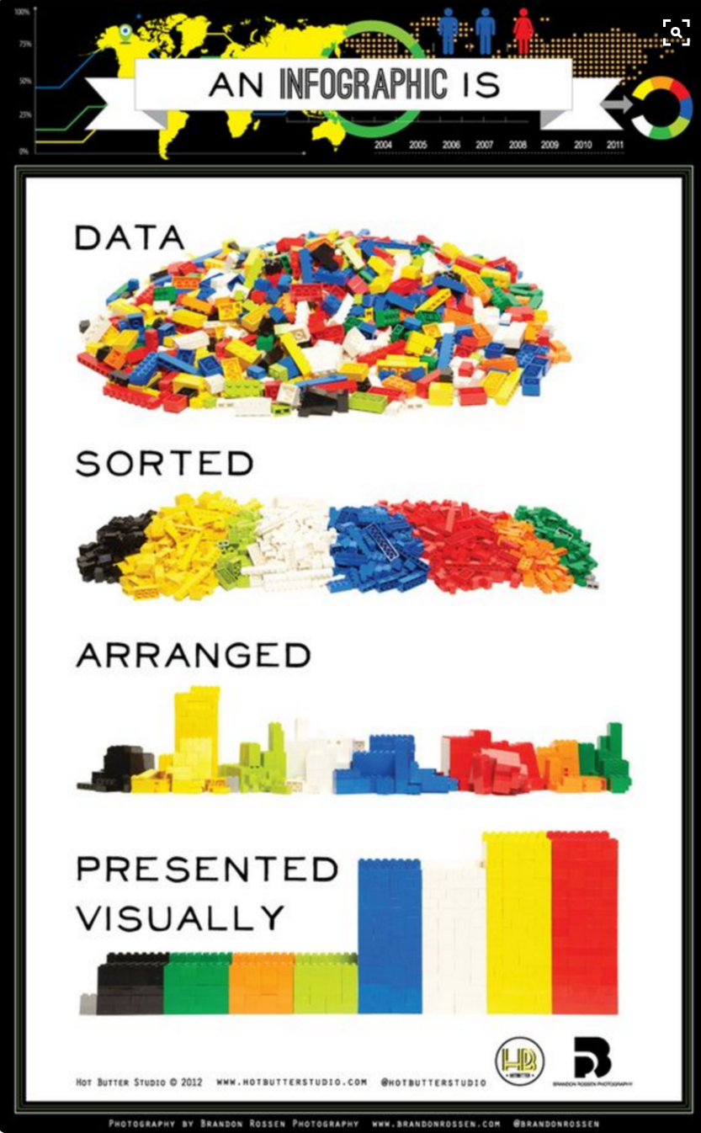  Y6 QR Codes :Look at the history of QR codes and the pros and cons of older style barcodes used in supermarkets.  Learn about how they work. Use a QR Code Generator to create messages. This video features a use of QR codes for xmas messages. Students could create QR codes for mothers or father’s day, representing each letter of the alphabet for a Reception class, or for creating a story book with a QR secret word or message for a younger class. Ask students to come up with a use for QR codes.

KEY CONCEPTS | YEARS F-2 | YEARS 3-4 | YEARS 5-6
Understanding digital systems  Using digital systems | Recognise and explore digital systems (hardware and software components) for a purpose (ACTDIK001) | Identify and explore a range of digital systems with peripheral devices for different purposes, and transmit different types of data (ACTDIK007) | Examine the main components of common digital systems and how they may connect together to form networks to transmit  data (ACTDIK014)
 | Y1 Knowing and Understanding Digital Systems: Students explore why do we use types of technologies? Students pick a technology and describe what it is used for. We make a class book about technologies.  Name and explain the function of a mouse, touch pad, touch screen, Interactive TV, keyboard and stylus.  Foundation Using Digital Systems: Practice logging on and off personal computer. Use different pathways to access and open selected software.  Play the game “Fuzz Bugs”. http://www.abcya.com/counting_sorting_comparing.htm  This is to develop and enhance mouse control.  Use 2 Publish software to create and publish a template. Use drawing tools to create a picture of own choice.  Learn how to manage apps on iPad, opening and closing.  Use the camera tool on iPad to take images, delete unwanted images.  Y1 Using Digital Systems: Use the camera tool on iPad to take images, delete unwanted images.  Explain to students that the SAC Newsletter  is “online” and what that means. Show  students how to locate it. After demonstrating  how to locate the newsletter and encourage  students to do this independently and at  home (to show their parents).  Ask students what they know about “email” or  “emails”. Who gets them? When do they get  them? Why do people get them?  Explain that every student at SAC has their  own personal email that can be accessed  using their username and password.  Demonstrate how to access a student email  account. Highlight again why username and  password security is a must! Discuss their  Digital Footprint.  Play with interactive robotic devices (BeeBots & BlueBots) to determine which ones can work with other devices. Name and label functions of parts.  Y2 Using Digital Systems: Investigate robotic devices (Cublets) and communicate to an adult what each one does using annotated drawings.  - Y2 Capturing and organising data: Use iPad app Popplet to capture images of water (linked to Science) and organise using a concept map.  - Use the Internet to download images and inserting them into a document, saving and retrieving at a later data.  - Use email to attach and send documents. | Y3 Capturing different types of data: Using Surface Pro, capture still images and video recordings for different purposes.  Y4 Using digital systems: Use Office 365 Word Online to collaboratively share ideas.  Use Yammer to collaboratively collate information for an assignment.  Y 4 Hardware/ Software: As an introductory lesson students could view a video like "What is a Computer". Depending on the level (as it is a little formal, teachers could pause the video at certain points and unpack the information or stop the video at a certain point, or re-create the information for children in a different way). Have students call out associated terminology such as “data”, “hardware” and the teacher writes these on the board. Using a two columns, can the class distinguish the differences and similarities between hardware and software? | Y5 Inside a Computer:  Explore and discuss old technologies:  https://www.youtube.com/watch?v=PF7EpEnglgk,  Students explore the inside parts and functions of a computer (PSU, CPU, GPU, RAM, motherboard, hard drive, expansion slots, expansion Cards). Students can re-create the parts of a computer and label the parts using drawing software, hard materials (boxes, crafts), or by drawing.  Students could create puppets or costumes and role play the parts of the computers and how they transmit data to a younger class.  Click view: How computer data is stored  Y5 Networks: Students explore how we connect to the Internet and how data is transmitted through a range of video resources. Invite a member of IT to give a short talk to students and show them the school servers.  Click view: What is the internet  Click View: How the internet works.  Click view: How search works  Y5 Domain Suffixes: Students explore domain suffixes and how these can be used to determine credibility of a a website. Domain suffixes to explore include .com. .edu , .org , .gov). Video resource LINK.  Students enter the topic ‘pollution’, look at the domain suffixes of the results and compare the information on various pages.

KEY CONCEPTS | YEARS F-2 | YEARS 3-4 | YEARS 5-6
Creating and Interacting Online (cyber safety, copyright) | Create and organise ideas and information using information systems independently and with others, and share these with known people in safe online environments (ACTDIP006) | Plan, create and communicate ideas and information independently and with others, applying agreed ethical and social protocols (ACTDIP013) | Plan, create and communicate ideas and information, including collaboratively online, applying agreed ethical, social and technical protocols (ACTDIP022)
 | FOUNDATION  ABCYA.com Cyber Five  How to close a pop up video.  Y1 Interacting Online:  Discuss the need to keep their log in details  private (Only to be shared with Parent /  Guardian / Teacher).  Discuss and highlight how never to enter their personal information online at all and if these details are requested to get permission from a parent / guardian or teacher. Hectors World Episode 1: https://vimeo.com/113866886  Explain that when we are worried or in trouble we turn to trusted adults. Discuss who these adults are. Highlight that it is the same when online. We need to show the screen to adults. Hectors World Episode 2:  https://vimeo.com/113867333  Y1 Safe ergonomic practices: Students recognise safe ergonomic practices when they are playing with information systems. Model and demonstrate how students should sit when using a computer. Explain that they should have regular breaks when at home and that teachers will provide breaks between activities at school.  Y2 Interacting Online: Students  recognise and discuss the need for cyber-safety when using online information systems.. Hectors World, computer security program. | Y3 Cyber Bullying:  Hector’s World Cyber Bullying online program.  My Online Neighbourhood video resource  Faux Paws Techo Cat video resources  Y3 Gaming Online:  Excellent resource call Lee and Kim which explains how to gaming online with others works.  Y4 Cyber Bullying:  Learn with Clicky, NetSmart online program.  Privacy Playground: First Adventures of the Three Cyber Pigs Media Smarts online program.  Rewrite your story.  Y4 Online Games to teach cyber safety:  Get Wise Online  Safety Land  Y4 Online Safety Videos:  NetSafe  Understanding Online Friends  ThinkUKnow  Y4 Digital Citizenship:  Watch video, what is digital citizenship? Students then create a digital footprint. To do this, distribute two blank sheets of paper to each student. Have students place the paper on the ground and trace their right foot. Ask students to write their full name at the top of the drawing so it is clearly identified as theirs. In the blank space inside the foot outline, ask students to write all the things they would like to be and want known about them. These might include values; such as good, kind, helpful, brave, a good friend, or aspirations for their futures; such as doctor, animal trainer or artist.  Then with the other sheet of paper, have students trace their left foot and also title this with their full name. In the blank space inside the left foot outline, ask students to consider and record - what do you not want known? The focus on here is on privacy as well as reputation, so lead your class to answers which include their home address, name of school, phone number and other identifying details.  Students are given a multiple choice test to complete about being good digital citizens. Link this with the Civics and Citizenship unit. Talk about when becoming a citizen of a country, people must first pass a test designed to ensure that they understand both the rights and responsibilities of citizenship. Being a good digital citizen means understanding what you are entitled to and what you are responsible for in an online environment.  Y4 Online Referencing Generator:  http://www.slasa.asn.au/org/ | Y5 Copyright basics:  Use this online resource as a teacher background to copy right basics.  The Australian Communications and Media Authority (ACMA) have the power to enforce content restrictions on Internet content hosted in Australia and maintain a "black-list" of overseas websites which is then provided for use in filtering software. Discuss with students why they think such regulations are in place?  In addition, the ACMA also has the power to block sites which contain copy right material. So, what is copy right?  https://www.youtube.com/watch?v=YtJdfHXk_u8  Copyright is a form of legal protection automatically provided to the authors of “original works of authorship,” including literary, dramatic, musical, and artistic work.  However, some people like to share their work with others. This is why Creative Commons was established. Creative commons allows creators of work to create a licence for their work.  Licencing is when a copyright owner gives permission for someone else to do something normally restricted by copyright law. For example, the creator of a song may license a song to an advertising agency, allowing the ad company to use parts of her song in a television commercial in exchange for compensation.  https://www.youtube.com/watch?v=8YkbeycRa2A  Follow this link and practice making your own Creative Commons Licence. More information on Creative Commons Licence LINK.  Resource for teachers, follow this LINK to Smartcopying.  Y5 Social Media:  https://www.youtube.com/watch?v=SgNIIUD_oQg  As a class, list the social media students are currently using. Tally how many students have read the terms and conditions of the social media services they are using. Choose a social media site and read the terms and conditions. Summarise the terms and conditions by creating a 'Did you know?' poster. Reflect and write: What are your responsibilities as a user of social media?  Y6 Creating digital content- legalities: Henry's Story about creating digital content. This is could be a video for starting a discussing about the legalities of downloading and using content for creation- is what Henry did okay? Students could research the topic.  Go through ‘google, referencing and plagiarism  slides of the power point and discuss as a class.  Students then need to develop the top 5 points for  searching and referencing using the internet and  record it in their books. Go through the slide with  information about verifying a reliable source,  Email students the ‘reliable source task’ and get them  to visit the two links and fill in the details to uncover  which of the 2 websites is more reliable and write a  short reflection outlining why?  Digital footprint online course.  Y6 Netiquette Resources:  Playing nice on the Internet video  Digital Dossier video  Gotta Share video (humour intended, see if students get it).  BrainPop video  Y6 Cyber Safety Online Program/Games:  Budd:e Primary online program  Y6 Social Media Activity:  Distribute the social media roles handout and discuss what is happening in the facebook conversations. Task: In the following examples, indicate who is exhibiting bullying behaviour. Who is a ‘bystander’? Who is responding appropriately? For those who are communicating inappropriately, how could they have contributed differently? Re-write those comments that could make a more positive contribution.  Y6/Y7 Social Media Videos to support teaching:  Social Media  FunMoods  Posting pictures online  Oversharing  Oversharing 2  ThinkUKnow  BTN Screen addiction  BTN Internet Trolls  Y6 Exploring Plagiarism:  Read Write Think Lesson Activity  Royalty Free Sites for students to use:  Bensound  Purple Planet  Soundbible  Jamendo  Free Music Archive  Incompetech  Pics4 Learning  Photopin  Pixabay  Y7 Cyber Safety Online Program/Games:  Budd:e Secondary online program

KEY CONCEPTS | YEARS F-2 | YEARS 3-4 | YEARS 5-6
Algorithms | Follow, describe and represent a sequence of steps and decisions (algorithms) needed to solve simple problems (ACTDIP004) | Define simple problems, and describe and follow a sequence of steps and decisions (algorithms) needed to solve them (ACTDIP010)  Implement simple digital solutions as visual programs with algorithms involving branching (decisions) and user input (ACTDIP011) | Design a user interface for a digital system (ACTDIP018)  Design, modify and follow simple algorithms involving sequences of steps, branching, and iteration (repetition) (ACTDIP019)  Implement digital solutions as simple visual programs involving branching, iteration (repetition), and user input (ACTDIP020)
 | Foundation Coding resources:  Using iPad app, Kodable , get Blue Fuzz through the maze. Free online Kodable lessons for teachers. Then use a harder iPad app, Bee-Bot app ,to get BeeBot through the maze.  Students use Bee-Bots with structured mats to record intended program and then test.  Y1 Coding Resources: Students can also use BeeBots (structured and unstructured tasks) but begin to progress from the Kodable app.  Online resources:  Code.org  Unplugged resources (Happy Maps and Move it Move it)  Y2 Coding Resources:  Scratch Junior app on iPads.  What is coding video (Scratch Junior).  Make a Sun tutorial for teachers.  Tickle iPad app.  Tynker iPad app.  Hello Ruby  Click View: What is Coding?  Click View: How to break down problems.  Y2 Programming robotic devices:  Peer mentoring with Y5 classes. In peer groups, students explore BeeBots, BlueBots, Dot and Dash, WeDo2 and Cublets.  Y2 Binary: Building foundations for binary counting in mathematics: recognising patterns in numbers (e.g. recognising number patterns increasing by 2s, 4s, 8s), it could be explained that computers use these groupings. | Y3 Coding without devices:  Super hero game creation idea.  Y3 Coding Software:  Scratch junior  Y3 Programming Robotic Devices:  Students use Dot and Dash and iPad to code movements using app Tickle.  Y3 Programming Minecraft: Students buddy up with an older year level for peer mentoring of Minecraft and mods.  Free online Minecraft Lessons. Online course, Code.org Minecraft Hour Tutorials.  Y3 Online coding resources:  Code.org Code Monkey  Code.org Basketball  Y4 Introduction to coding:  Click view: What is an algorithm  Click view: How to break down problems  Click view: What are variables  Click view: How to write complex programs  Y4 Coding with Scratch:  Code.org Make Music with Scratch.  Code.org Make it fly with Scratch  Shaun the Sheep  Y4 Online coding resources:  Blockly Games  Code.org Moana  Code.org Frozen  Itch Bounce with Scratch  Pencil Code Gym  Robo Boogie  Y4 Binary, multiple representations for a number: Exploring different ways that a number can be represented. Recognising the multiple many ways to record a number, such as by 2 + 7= 9 or 4+4+1= 9, 3+3+3=9, or 3X3=9, etc as well as visual representations; focus on patterns in 2 x tables, 4 times tables.  Y4 Programming Robotic Devices: Students use iPads and WeDo2 kits to build and program robots. Online coding resource to support this is Move Bit By Bit. | Y5 Design a game user interface: What makes a good gam LINK.  Students begin by being taught how to create a multi level maze game, Ping Pong and Space Invaders game using Scratch. Students are then asked to create their own game using Scratch and publish it online using the following criteria:  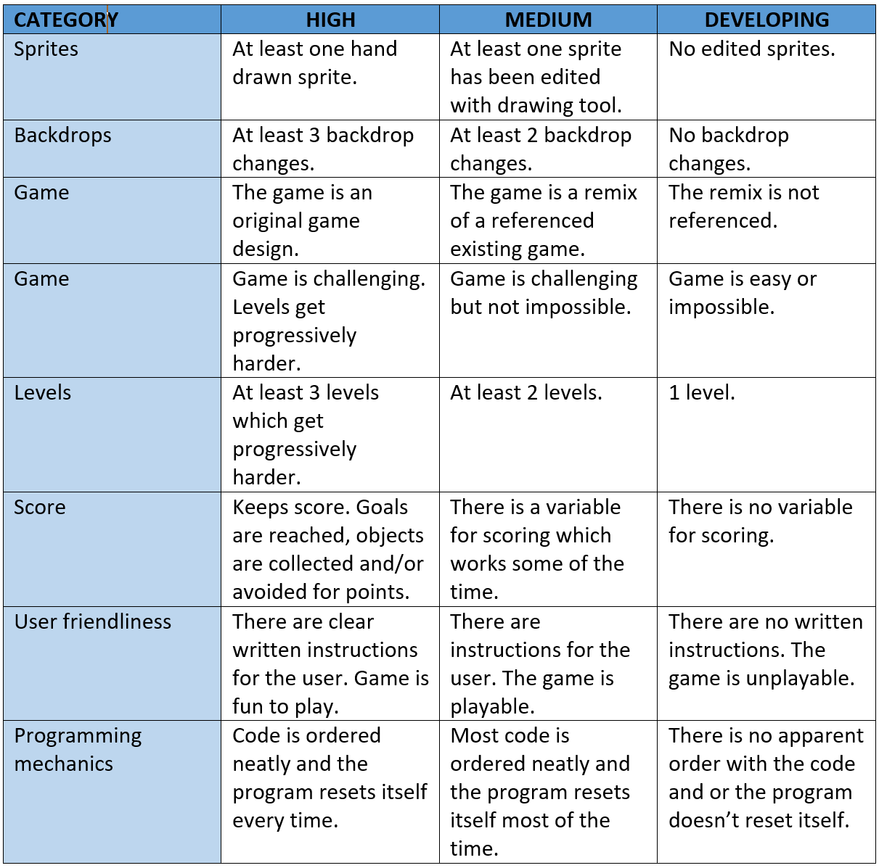  Students are then introduced to Gamestar Mechanic  (Game Star Mechanic ) to design a multiple level game interface with the focus on game design rather than coding. GameStar Mechanic tutorial video link. Things for students to focus on for game design include; Storyline/goal, gameplay, framing, colour, game mechanics.  Y 5 Modems: When binary digits need to be sent across phone lines, they are converted to sound. Play a sound of a modem from the internet. This activity by CS Unplugged explores how high and low sounds (pitch) are used to transmit data. This activity links well with Music and Media Arts unit.  Y5 Online Coding Games:  Code.org Flappy Bird Game  Made with Code Google  Code Monster  Cruchzilla  Code.org Star Wars  Extension:  Kahn Academy Draw with code (Java script)  Codeglaboria (Java Script)  Puzzle script  Y6 Online Coding Software (runs in browser):  Waterbear Playground  Snap! (advanced version of Scratch)  How to make a snake in Java Script  Codemoji  Code.org Text compression  Code.org (Python) Turtle graphics  Pengee (Python) hour of code  Code.org Infinity Play Lab  Codesters coordinate plane  3D frogger  Y6 Binary: Teacher could begin introducing to students that computers count in 0s and 1s.Use little blocks to teach students about binary (grouping the blocks in 1, 2, 4, 8, etc and exploring the patterns as a class).  Students play around with flipping cards based on the CS Unplugged binary lesson. Depending on previous experience with counting in binary, introduce students to counting in 0s and 1s. An example of an activity is taken from CS unplugged. Students are given coloured cards with the numbers 32, 16, 4, 2, 1 and small matching 0s and 1s. Discuss the pattern in this data, have students flipping cards over from memory (e.g. flip 16, then 3- have students try to create ‘3’ using what they have). Slowly move this activity toward flipping the 0/1 card to a 1 if the number is in use.  Have students work through a task like the Bitmaps Images. Have students design and create their own bitmap images on large graph paper (can be based on their favourite characters, shapes, a theme). Collect and hand out the bitmap images randomly. Students solve the images.  Binary code necklace.  Coding conditionals resources for teachers.  Y6/Y7 Coding Downloadable Free Programs:  Snap! (extension of Scratch)  Kodu (Microsoft)  Storyboarding and coding with Alice 3

KEY CONCEPTS | YEARS F-2 | YEARS 3-4 | YEARS 5-6
How and why people use information systems | Explore how people safely use common information systems to meet information, communication and recreation needs (ACTDIP005) | Explain how student solutions and existing information systems meet common personal, school or community needs (ACTDIP012) | Explain how student solutions and existing information systems are sustainable and meet current and future local community needs (ACTDIP021)
 | Year 1: Students are asked: What is  communication? How do you  communicate? (age appropriate) How do  your parents or older siblings  communicate? How do teachers communicate through the school?  Ask students how and why do we share  information. Who do we share  information with? When would we need  to share information? (newsletters,  meetings, music lesson, sport training  etc) Try and keep this as applicable as  possible to children and families. Lead  discussion to things that would directly  relate to them of that impact them and  their families.  What are the different ways we can  share information at: school, home, with  family, family interstate or overseas, wider community, Australia.  Brainstorm, discuss and highlight current  methods to share information. (Record  in books).  Using survey provided (or create one of  your own) survey students and their  family in regards to information sharing  and communication systems (and how  they have changed over time).  Y2 Information systems of the past: Students share ideas about the ways information systems are being used by families and friends in everyday life, for example comparing current digital play equipment with play equipment of 20 years ago. Brainstorm what types of technologies people use to communicate. How do they differ from one another? Ask family members as a homework activity to tell the student how they communicated when younger. Record and share in class. Have a class discussion about how these methods differed to the ones brainstormed in the above activity.  Click View: How computers have changed overtime , PDF to support teachers. | Year 3 Technology at the museum:  Visit the local museum and investigating how information systems are used. Students record different types of technology and display systems.  Year 4 Library e-books:  Students create a short survey using Microsoft Forms and collect data about how many students use the online library borrowing system to download e-books and why they do or do not.  Year 4 Speech recognition software:  Investigate how speech recognition software can help speakers whose language background is not English.  Year 4 Plants in Action (Primary Connection Science Unit):  During science students keep a record of plant growth (still images) and create a stop animation. Students then create a table and records hardware/software used and how it was used.  Name of hardware/ software What did this hardware help you to do? What else might this hardware help you with?  Video camera  Microsoft pen  Fresh Paint app | Year 5 Sustainable solutions:  Teachers use Microsoft SharePoint to establish a student portal. Students can then download worksheets rather than the class teacher printing worksheets. Students can then annotate documents electronically on their device.  Utilise OneDrive for sharing work with class teacher or Microsoft OneNote.  Year 5 Explore Touch Systems:  Students explore why people interact so readily with touch systems. Investigate where are touch systems used in our environment?  How does a touchscreen work, video LINK.  How touchscreens work, video link 2.  What does a Microsoft pen look like on the inside video LINK.  Discuss, how might touch screen help users? What experiences do they offer compared to a non-touch screen.  Visit the super market and or rail road station, view touch screens in action. Students create a flow chart explaining how to operate a particular type of touch screen.  Year 6 Global positioning system (GPS):  Students consider how an electronic tracking system such as a global positioning system (GPS) could be used to help people in the community.  Students research and explore how Pokémon Go works. Why has it been such a big success?

