ASSESSMENT RUBRIC FOR SCRATCH GAME
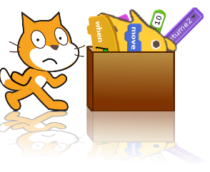
Task: Design a game using scratch with multiple levels.
CATEGORY | HIGH | MEDIUM | DEVELOPING
Sprites | At least one hand drawn sprite. | At least one sprite has been edited with drawing tool. | No edited sprites.
Backdrops | At least 3 backdrop changes. | At least 2 backdrop changes. | No backdrop changes.
Game | The game is an original game design. | The game is a remix of a referenced existing game. | The remix is not referenced.
Game | Game is challenging. Levels get progressively harder. | Game is challenging but not impossible. | Game is easy or impossible.
Levels | At least 3 levels which get progressively harder. | At least 2 levels. | 1 level.
Score | Keeps score. Goals are reached, objects are collected and/or avoided for points. | There is a variable for scoring which works some of the time. | There is no variable for scoring.
User friendliness | There are clear written instructions for the user. Game is fun to play. | There are instructions for the user. The game is playable. | There are no written instructions. The game is unplayable.
Programming mechanics | Code is ordered neatly and the program resets itself every time. | Most code is ordered neatly and the program resets itself most of the time. | There is no apparent order with the code and or the program doesn’t reset itself.
Australian Curriculum Content Descriptors (Y5-6):
Design a user interface for a digital system (ACTDIP018)
Design, modify and follow simple algorithms involving sequences of steps, branching, and iteration (repetition) (ACTDIP019)
Implement digital solutions as simple visual programs involving branching, iteration (repetition), and user input (ACTDIP020)

