Maze code explained:

0

-90

90

Code for when press up arrow, go upwards 10, if increase number will go higher up

Code for when press down arrow, go downwards 10, if up

180

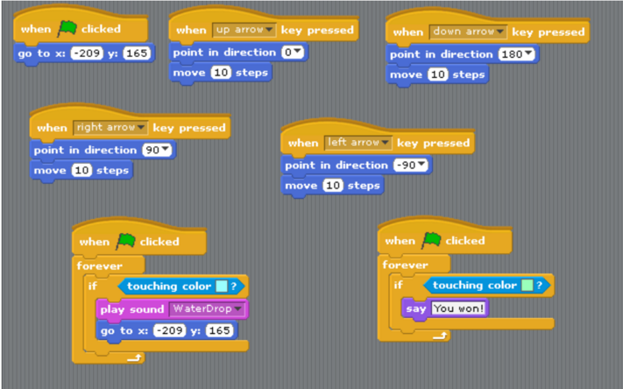

If sprite touches blue, it says you won!

If sprite touches blue, a water drop sound will play and the sprite will be reset at the starting position

Code for when press left arrow, go left 10 (notice – not + number)

Code for when press right arrow, go right 10