Year 5 Unit Plan: Bushfires
Topic | Bush fires |  | Length: 6 weeks
Year level descripion | Australian communities – their past, present and possible futures  The Year 5 curriculum focuses on colonial Australia in the 1800s and the social, economic, political and environmental causes and effects of Australia’s development, and on the relationship between humans and their environment. Students geographical knowledge of Australia and the world is expanded as they explore the continents of Europe and North America, and study Australia’s colonisation, migration and democracy in the 1800s. Students investigate how the characteristics of environments are influenced by humans in different times and places, as they seek resources, settle in new places and manage the spaces within them. They also investigate how environments influence the characteristics of places where humans live and human activity in those places. Students explore how communities, past and present, have worked together based on shared beliefs and values. The curriculum introduces studies about Australia’s democratic values, its electoral system and law enforcement. In studying human desire and need for resources, students make connections to economics and business concepts around decisions and choices, gaining opportunities to consider their own and others financial, economic, environmental and social responsibilities and decision-making, past, present and future.  The content provides opportunities for students to develop humanities and social sciences understanding through key concepts including significance; continuity and change; cause and effect; place and space; interconnections; roles, rights and responsibilities; and perspectives and action. These concepts may provide a focus for inquiries and be investigated across sub-strands or within a particular sub-strand context.  The content at this year level is organised into two strands: knowledge and understanding, and inquiry and skills. The knowledge and understanding strand draws from four sub-strands: history, geography, civics and citizenship and economics and business. These strands (knowledge and understanding, and inquiry and skills) are interrelated and have been developed to be taught in an integrated way, which may include integrating with content from the sub-strands and from other learning areas, and in ways that are appropriate to specific local contexts. The order and detail in which they are taught are programming decisions.
Achievement standard | By the end of Year 5, students describe the significance of people and events/developments in bringing about change. They identify the causes and effects of change on particular communities and describe aspects of the past that have remained the same. They describe the experiences of different people in the past. Students explain the characteristics of places in different locations at local to national scales. They identify and describe the interconnections between people and the human and environmental characteristics of places, and between components of environments. They identify the effects of these interconnections on the characteristics of places and environments. Students identify the importance of values and processes to Australia’s democracy and describe the roles of different people in Australia’s legal system. They recognise that choices need to be made when allocating resources. They describe factors that influence their choices as consumers and identify strategies that can be used to inform these choices. They describe different views on how to respond to an issue or challenge.  Students develop questions for an investigation. They locate and collect data and information from a range of sources to answer inquiry questions. They examine sources to determine their purpose and to identify different viewpoints. They interpret data to identify and describe distributions, simple patterns and trends, and to infer relationships, and suggest conclusions based on evidence. Students sequence information about events, the lives of individuals and selected phenomena in chronological order using timelines. They sort, record and represent data in different formats, including large-scale and small-scale maps, using basic conventions. They work with others to generate alternative responses to an issue or challenge and reflect on their learning to independently propose action, describing the possible effects of their proposed action. They present their ideas, findings and conclusions in a range of communication forms using discipline-specific terms and appropriate conventions
Content Descriptors | INQUIRY AND SKILLS  Develop appropriate questions to guide an inquiry about people, events, developments, places, systems and challenges (ACHASSI094)  Locate and collect relevant information and data from primary sources and secondary sources(ACHASSI095)  Examine different viewpoints on actions, events, issues and phenomena in the past and present (ACHASSI099)  Evaluate evidence to draw conclusions (ACHASSI101)  Present ideas, findings, viewpoints and conclusions in a range of texts and modes that incorporate source materials, digital and non-digital representations and discipline-specific terms and conventions (ACHASSI105)  KNOWLEDGE AND UNDERSTANGING  The impact of bushfires or floods on environments and communities, and how people can respond (ACHASSK114)
General Capabilities | Critical and creative thinking  Identify and clarify information and ideas  Organise and process information  Personal and social capability  Appreciate diverse perspectives  Contribute to civil society | Report 2 Outcome  - Identifies the impact of bushfires or floods on environments and communities, and how people can respond
HEALTH | By the end of Year 6, students investigate developmental changes and transitions. They explain the influence of people and places on identities. They recognise the influence of emotions on behaviours and discuss factors that influence how people interact. They describe their own and others’ contributions to health, physical activity, safety and wellbeing. They describe the key features of health-related fitness and the significance of physical activity participation to health and wellbeing. They examine how physical activity, celebrating diversity and connecting to the environment support community wellbeing and cultural understanding.  Students demonstrate fair play and skills to work collaboratively. They access and interpret health information and apply decision-making and problem-solving skills to enhance their own and others’ health, safety and wellbeing. They perform specialised movement skills and sequences and propose and combine movement concepts and strategies to achieve movement outcomes and solve movement challenges. They apply the elements of movement when composing and performing movement sequences.  CONTENT DESCRIPTOR  Plan and practise strategies to promote health, safety and wellbeing(ACPPS054)

Week | Learning & teaching strategies | Assessment | Resources
1 | ​​Think, pair and share  What do you know about bushfires? What have you seen on the TV, heard on the radio or read in the newspaper? Maybe you know someone who has been affected by a bushfire.  ​TASK: Draw a concept map on 2 A3 pieces of paper stuck together  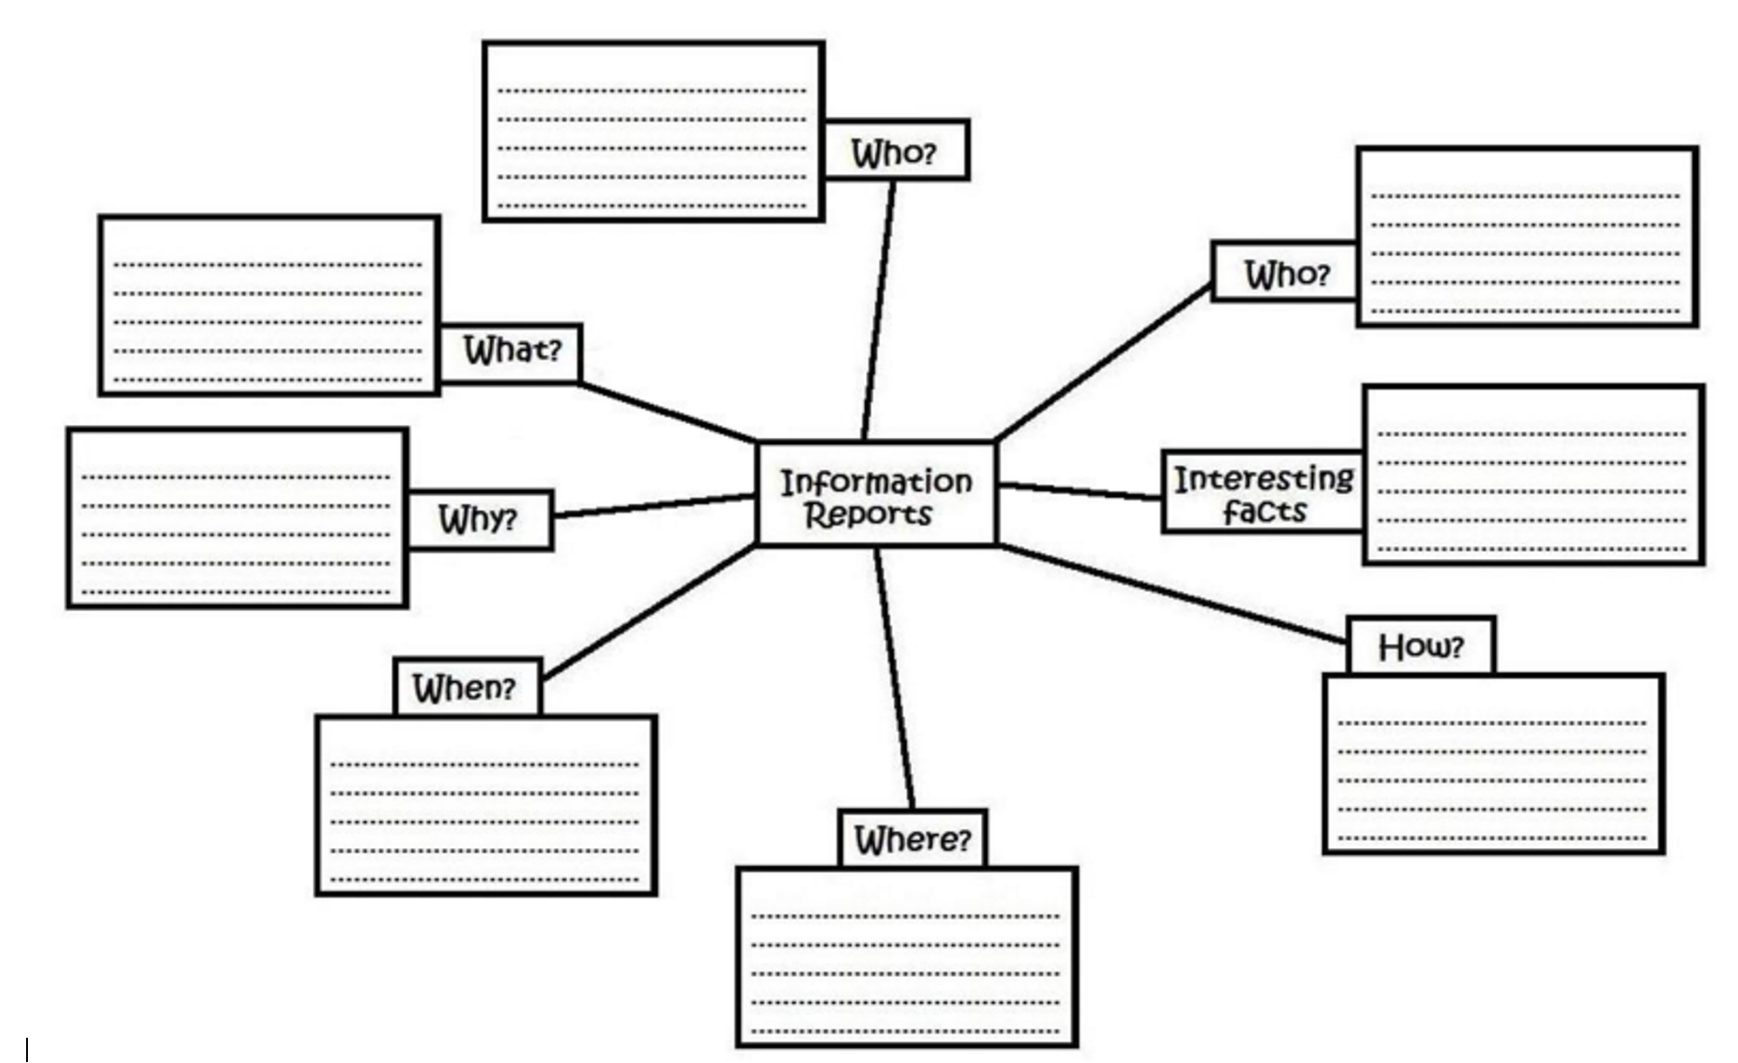  As a class, read  What is a bushfire.docx  Fire Intensity.docx  Watch, what a bushfire might look like https://www.youtube.com/watch?v=BM_mrXvxndg  Play http://www.cfa.vic.gov.au/kids-schools/secondary-schools/interactive/#/enter and add notes to concept map  Visit the Australian Government site about bushfires. In groups read, and then individually add notes to your concept map. https://schools.aemi.edu.au/bushfire/about-bushfires |  | What is a fire word doc.  Fire intensity word doc  A3 paper  https://www.youtube.com/watch?v=BM_mrXvxndg  http://www.cfa.vic.gov.au/kids-schools/secondary-schools/interactive/#/enter  https://schools.aemi.edu.au/bushfire/about-bushfires
2 | Topic: When and where do bushfires occur in Australia?  Paste the ABC Splash URL below into a new web browser and watch a video about climate and fires in Australia.  http://splash.abc.net.au/home#!/media/30033/​  Go to Share Point page https://portal.sac.sa.edu.au/sites/studentlearn/Year5/SitePages/Bushfires%20Y5.aspx and scroll to the bottom. Briefly discuss the 3 bushfires students may choose to base their information report on.  ‘Extinguishing fires’ and ‘Types of fires’ word documents. Students add any additional notes to their concept map.  View and discuss interactive disaster map website. https://disastermapper.ema.edu.au/#/category/2  Topic: How can bushfires affect people’s lives and how might we reduce bushfires?  Paste the ABC Splash URL below into a new web browser and watch a video about preparing for a bushfire.  http://splash.abc.net.au/home#!/media/31104/​  Visit Kid's Health, read and discuss as a class. Think, pair, share any questions or thoughts.  http://www.cyh.com/HealthTopics/HealthTopicDetailsKids.aspx?p=335&np=288&id=2724  Paste the ABC Splash URL below into a new web browser and watch a video about megafires and bush fire impact ecosystems.  http://splash.abc.net.au/home#!/media/31023/​​  Topic: How can bushfires affect people’s lives and how might we reduce bushfires?  Discuss, what is the Fire Danger Rating system? What are the colours, what do they mean? Where is it found? When is it used?  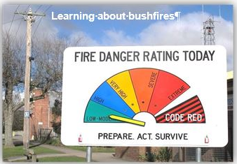  Download the Victorian fire danger rating brochure. Click the link below and go to the South Australian fire ban and rating website. http://www.cfs.sa.gov.au/site/fire_bans_and_ratings.jsp  Compare the two. Are there any similarities or differences?  Students complete bushfire comic link THE GAME LINK |  | http://splash.abc.net.au/home#!/media/30033/​  Extinguishing fires’ word doc  Types of fires word doc  http://splash.abc.net.au/home#!/media/31104/  http://www.cyh.com/HealthTopics/HealthTopicDetailsKids.aspx?p=335&np=288&id=2724  https://disastermapper.ema.edu.au/#/category/2  http://splash.abc.net.au/home#!/media/31023  Victorian fire danger rating brochure  http://www.cfs.sa.gov.au/site/fire_bans_and_ratings.jsp
3 | Topic: What if bushfires aren’t likely to affect me? How can I reduce the risk of and stay safe at home in case of a fire?  (headphones required): Students play http://kids.triplezero.gov.au/ fire games  Watch and role play https://www.youtube.com/watch?v=DcFCY1OFhCw and https://www.youtube.com/watch?v=-TH0VlerGgA  Students talk about and draw a fire evacuation plan with their parents. They need to include a common meting point.  GUEST SPEAKER: Caroline Lewis will speak to the class about the Adelaide Hills bush fires. New auditorium needs to be booked and a mutual time for all 3 classes arranged. Approximate time is 1 ½ lessons.  Students choose a bushfire (Ash Wednesday, Victoria 2009 or Adelaide Hills bushfires). Using resources on SharePoint students research and add note to their concept map.  HEALTH ASSESSMENT: Draw a map of your home and clearly show a fire excavation plan. Include the most likely places where a fire might start and explain why. |  | http://kids.triplezero.gov.au/  https://www.youtube.com/watch?v=-TH0VlerGgA  Caroline Lewis  SharePoint page https://portal.sac.sa.edu.au/sites/studentlearn/Year5/SitePages/Bushfires%20Y5.aspx
4 -5 | 'What impact does a bushfire have on the Australian environment and communities and how can we prepare for them?'  Your task is to research one bushfire (Ash Wednesday, Black Saturday or 2015 Adelaide Hills)  Follow the following steps:  1. Come up with 4 guiding questions to help you answer the above question.  2. Using your guiding questions, research the topic using the school library website, sharepoint and a selection of books in the library  3. Once you have recorded your guiding questions on the proforma you need to take key notes on each question  4. You then need to write each section into separate paragraphs with subheadings.  5. Lastly you need to include an introduction and conclusion for your report.​  6. Include diagrams​ to help explain your paragraphs. ​  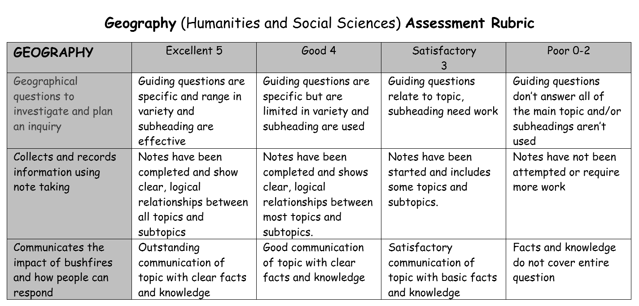 | Information report, see assessment rubric

