Year 5 Unit Plan: Geography
Topic | Factors that shape the human and environmental characteristics of places |  | Length: 8 weeks
Year level descripion | Australian communities – their past, present and possible futures  The Year 5 curriculum focuses on colonial Australia in the 1800s and the social, economic, political and environmental causes and effects of Australia’s development, and on the relationship between humans and their environment. Students geographical knowledge of Australia and the world is expanded as they explore the continents of Europe and North America, and study Australia’s colonisation, migration and democracy in the 1800s. Students investigate how the characteristics of environments are influenced by humans in different times and places, as they seek resources, settle in new places and manage the spaces within them. They also investigate how environments influence the characteristics of places where humans live and human activity in those places. Students explore how communities, past and present, have worked together based on shared beliefs and values. The curriculum introduces studies about Australia’s democratic values, its electoral system and law enforcement. In studying human desire and need for resources, students make connections to economics and business concepts around decisions and choices, gaining opportunities to consider their own and others’ financial, economic, environmental and social responsibilities and decision-making, past, present and future.  The content provides opportunities for students to develop humanities and social sciences understanding through key concepts including significance; continuity and change; cause and effect; place and space; interconnections; roles, rights and responsibilities; and perspectives and action. These concepts may provide a focus for inquiries and be investigated across sub-strands or within a particular sub-strand context.  The content at this year level is organised into two strands: knowledge and understanding, and inquiry and skills. The knowledge and understanding strand draws from four sub-strands: history, geography, civics and citizenship and economics and business. These strands (knowledge and understanding, and inquiry and skills) are interrelated and have been developed to be taught in an integrated way, which may include integrating with content from the sub-strands and from other learning areas, and in ways that are appropriate to specific local contexts. The order and detail in which they are taught are programming decisions.
Achievement standard | By the end of Year 5, students describe the significance of people and events/developments in bringing about change. They identify the causes and effects of change on particular communities and describe aspects of the past that have remained the same. They describe the experiences of different people in the past. Students explain the characteristics of places in different locations at local to national scales. They identify and describe the interconnections between people and the human and environmental characteristics of places, and between components of environments. They identify the effects of these interconnections on the characteristics of places and environments. Students identify the importance of values and processes to Australia’s democracy and describe the roles of different people in Australia’s legal system. They recognisethat choices need to be made when allocating resources. They describe factors that influence their choices as consumers and identify strategies that can be used to inform these choices. They describe different views on how to respond to an issue or challenge.  Students develop questions for an investigation. They locate and collect data and information from a range of sources to answer inquiry questions. They examine sources to determine their purpose and to identify different viewpoints. They interpret data to identify and describe distributions, simple patterns and trends, and to infer relationships, and suggest conclusions based on evidence. Students sequence information about events, the lives of individuals and selected phenomena in chronological order using timelines. They sort, record and represent data in different formats, including large-scale and small-scale maps, using basic conventions. They work with others to generate alternative responses to an issue or challenge and reflect on their learning to independently propose action, describing the possible effects of their proposed action. They present their ideas, findings and conclusions in a range of communication forms using discipline-specific terms and appropriate conventions
Content Descriptors | INQUIRY AND SKILLS  Develop appropriate questions to guide an inquiry about people, events, developments, places, systems and challenges (ACHASSI094)  Examine different viewpoints on actions, events, issues and phenomena in the past and present (ACHASSI099)  Evaluate evidence to draw conclusions (ACHASSI101)  Present ideas, findings, viewpoints and conclusions in a range of texts and modes that incorporate source materials, digital and non-digital representations and discipline-specific terms and conventions (ACHASSI105)  KNOLWEDGE AND UNDERSTANDING  The influence of people on the environmental characteristics of places in Europe and North America and the location of their major countries in relation to Australia (ACHASSK111)
General Capabilities | Numeracy:  Interpret maps and diagrams  Interpret data displays  Estimate and measure with metric units  Critical and creative thinking:  Identify and clarify information and ideas  Organise and process information  Ethical understanding:  Explore ethical concepts in context  Consider points of view  Literacy  Compose spoken, written, visual and multimodal learning area texts  Understand how visual elements create meaning  Technologies  Locate, generate and access data and information  Select and evaluate data and information  Select and use hardware and software | Report 2 Outcomes  - Constructs large and small scale maps  - Communicates the influence humans have on places in Europe and North America
Cross Curricular  Priorities | - Aboriginal & Torres Strait Islander histories & cultures  - Asia & Australia’s engagement with Asia  - Sustainability: Recognizing that people have significantly changed the natural environments of Europe and North America. Investigating options/actions that might be taken to ensure the sustainability of human activities such as water consumption, waste disposal. Appreciating that careful waste and resource management is a way of sustaining resources.

Week | Learning & teaching strategies | Assessment | Resources
1 | Maps can be drawn to represent a variety of information. Watch a click view introduction about maps. This information might include things such as roads, tourist attractions and campgrounds, or they might represent the latest weather patterns. The objects on a map are represented using symbols. A symbol is a picture on the map that represents something in the real world. Understanding these symbols requires the use of a key. Maps use a key, or legend, to explain the meaning of each of the symbols used in the map. These keys usually show a small picture of each of the symbols used on the map, along with a written description of the meaning of each of these symbols. (Text source)  CLASS TASK: There are many different countries that make up the world. These countries are found within the 7 continents of the world. A continent is a large area of land, which contains lots of countries.  Watch: https://www.youtube.com/watch?v=urr53arh--E  Watch: https://www.youtube.com/watch?v=pP0YyyzY4Yg |  | https://online.clickview.com.au/share?sharecode=1c3261c0  https://online.clickview.com.au/share?sharecode=b4bbbe92  https://www.youtube.com/watch?v=urr53arh--E  https://www.youtube.com/watch?v=pP0YyyzY4Yg  world map pdf  interactive globes for students to practice naming countries
2 | ​MAPPING SKILLS STUDENT TASKS  STEP 1: Download the world map. world map.pdf  STEP 2: Colour and create a legend showing Oceania, North America and Europe. These are the continents we will be focusing on.  STEP 3: ​Watch the video below about longitude and latitude.  https://www.youtube.com/watch?v=swKBi6hHHMA  STEP 4: On your world map, mark the equator, longitude and latitude. ​​​  STEP 5: Have a look at the PowerPoint below. It shows you key features of maps that you will need to know.  year 5 mapping skills.ppt​  ​STEP 6: Add a title (what is your map showing) , compass, Tropic of Cancer, Tropic of Capricorn, Southern Hemisphere, Northern Hemisphere.​  Student sample:  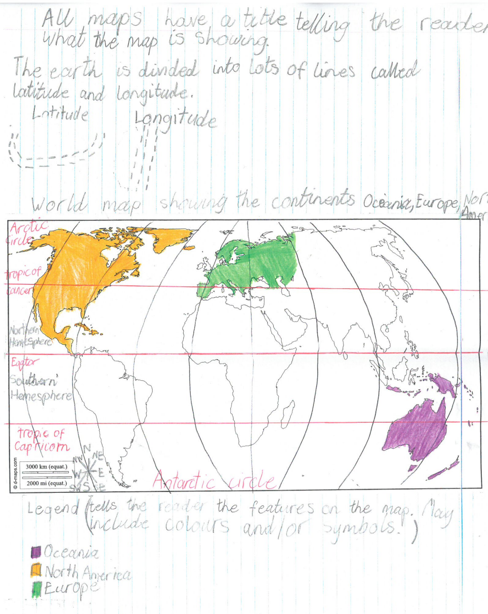 |  | SharePoint – geography  https://www.youtube.com/watch?v=swKBi6hHHMA  Individual blank world maps  PowerPoint
3 | THE LOCATION OF THE MAJOR COUNTRIES OF EUROPE  Europe​ is a continent in the Northern Hemisphere, consisting of 45 countries. Yes 45! (more than North America and Australia!)​  https://www.youtube.com/watch?v=Z8brpoU_HNI  https://www.youtube.com/watch?v=qdCu2sKhYfk  Student task: Download the political map of Europe below.  Europe_countries_named.pdf  Student task: Practice learning the location of the major countries of Europe. You will need to know this the location of the major countries of Europe as you will be given a test on this. |  | https://www.youtube.com/watch?v=Z8brpoU_HNI  https://www.youtube.com/watch?v=qdCu2sKhYfk
4 | THE ENVIRONMENTAL CHARACTERISTICS OF EUROPE  Student task: Download the maps below and save them in a folder.  Europe_countries_named.pdf  Map_Europe_Without_Borders.pdf  Europe average temperature map.docx​  Natural_Vegetation_Europe.pdf​  World_map_natural_hazards.pdf  Population density Europe Map.docx  Population density Europe Map 2.docx​  Student task: ​Create a concept map about Europe based on the information from the maps. Possible inquiry questions for your concept map might include:  - What is the climate like in Europe? Does it differ in countries?  - What are the major land formations in Europe?  - How does the population differ in European countries?  - Are there natural hazards in Europe? Where might they be found? Why?  Student task: After completing your concept map, write a summary paragraph for each of your inquiry questions. |  | Europe_countries_named.pdf  Map_Europe_Without_Borders.pdf  Europe average temperature map.docx​  Natural_Vegetation_Europe.pdf​  World_map_natural_hazards.pdf  Population density Europe Map.docx  Population density Europe Map 2.docx​
5 | THE LOCATION OF THE MAJOR COUNTRIES OF NORTH AMERICA  BACKGROUND INFORMATION: Maps are created to different purposes. Two types of maps which we are going to learn about are political maps and physical maps.  A political map shows human-created features such as boundaries, cities, highways, roads, and railroads.  Physical maps displays (shows) the natural features of the earth - the location and names of mountains, rivers, valleys, ocean currents, and deserts. ​​  For this part of our unit, we are going to focus on political maps.  The continent of North America has been divided into 23 independent countries, including island states in the Caribbean.  https://www.youtube.com/watch?v=rANAYYIYHbI  ​​Student task: Download the political map below which shows the countries of North America.  North America political map.pdf  Student task: Practice learning the location of the major countries of North Ameria. Colour the major countries and create a legend for your map.​ You will need to know this the location of the major countries of North America as you will be given a test on this.  ​​​Did you know that the countries are then divided into smaller zones called states. In the USA there are 50 states! Take a virtual tour below. Please note, you don't need to remember them all!  https://www.youtube.com/watch?v=_E2CNZIlVIg  https://www.youtube.com/watch?v=PJj2XC_CxNY  https://www.youtube.com/watch?v=LSOLUieKmfk |  | https://www.youtube.com/watch?v=rANAYYIYHbI  https://www.youtube.com/watch?v=_E2CNZIlVIg  https://www.youtube.com/watch?v=PJj2XC_CxNY  https://www.youtube.com/watch?v=LSOLUieKmfk
6 -7 | ENVIRONMENTAL CHARACTERISTICS OF NORTH AMERICA  ​WELCOME TO YOUR SPECIAL OPPS MISSION!  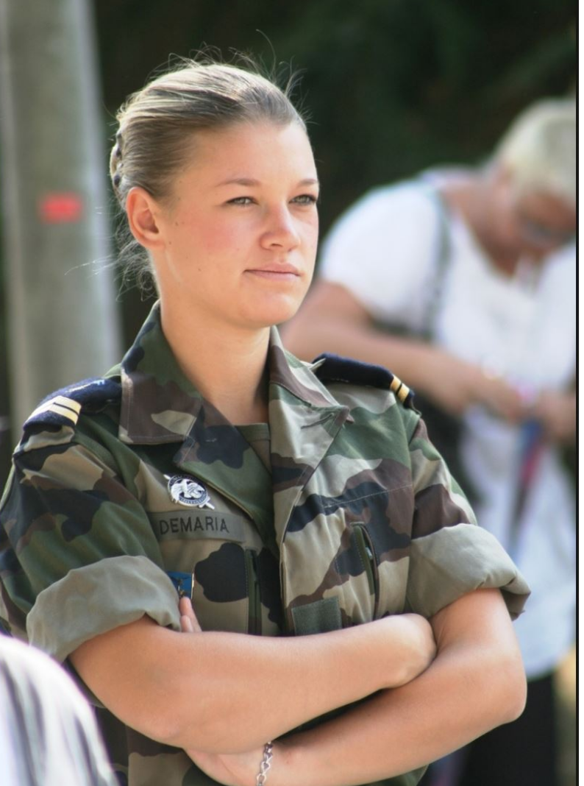  STEP 1: Watch this LINK​.  YOUR TARGET: North America  YOUR MISSION: Unlock two environmental characteristics of North America, one natural and one built.  THINGS TO CONSIDER:  What is there? Where is it? Why is it there? What are the effects? What was it like before? How is it changing? Should it be like this? What is the future?  YOUR AMMUNITION: Google Earth, the Internet, encyclopaedias, the library.  HOW MUCH TIME DO YOU HAVE?  1 lesson to explore North America, skim and scan, what is of interest to you?  1 lesson to work in a group, share ideas, thoughts and your mission strategy. Then write your own 8 inquiry questions, 4 for natural and 4 four your built characteristic . These will guide your research.  2 lessons for your natural and 2 lessons for your build environmental characteristic to research take notes. Note, notes must be submitted and keep an ongoing reference list of your sources.  2 lessons to prepare a visual paper based presentation, one for your natural and one for your built environmental characteristics. | Assessment on r-drive

