The features of the micro:bit
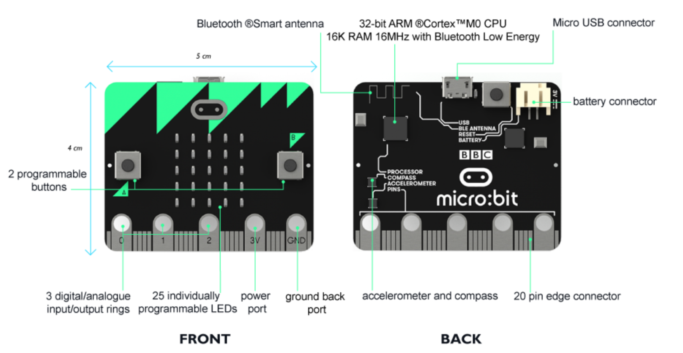
Source: http://microbit.org/guide/features/
LED
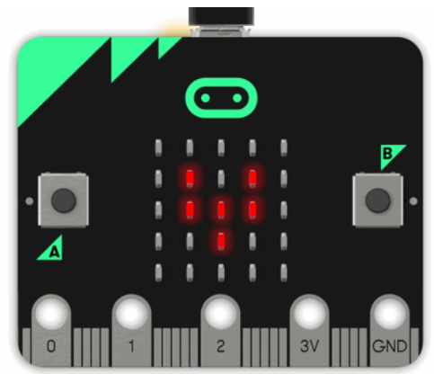
LED stands for Light Emitting Diode. The micro:bit has 25 individually-programmable LEDs, allowing you to display text, numbers, and images.
A and B Buttons
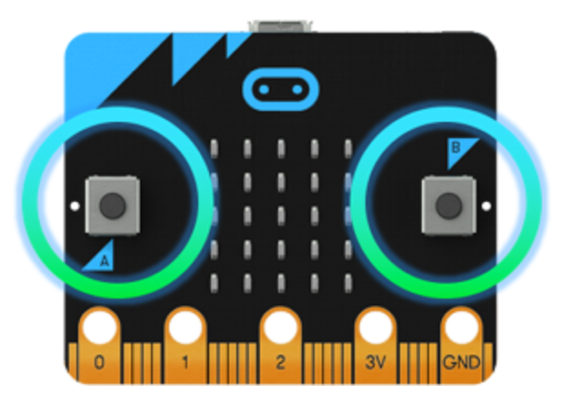
There are two buttons on the front of the micro:bit (labelled A and B). You can detect when these buttons are pressed, allowing you to trigger code on the device.

Pins
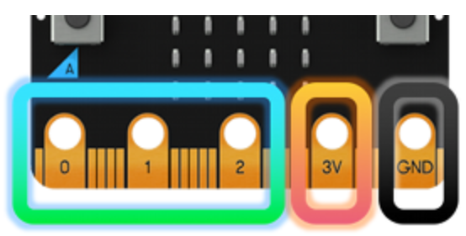T
There are 25 external connectors on the edge connector of the micro:bit, which we refer to as 'pins'. Program motors, LEDs, or other electrical components with the pins, or connect extra sensors to control your code!
Light sensor
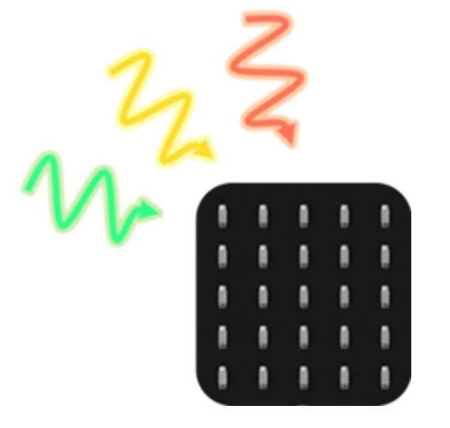
By reversing the LEDs of the screen to become an input, the LED screen works as a basic light sensor, allowing you to detect ambient light.
Temperature sensor
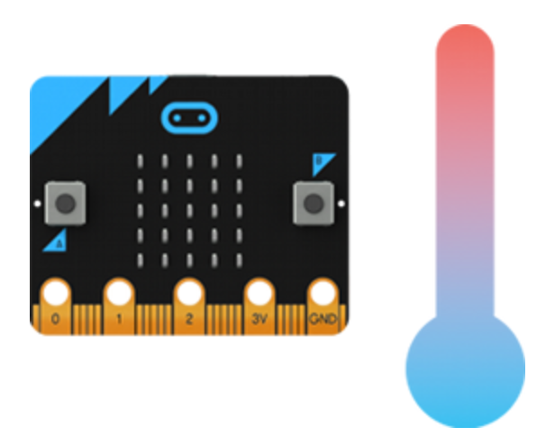
This sensor allows the micro:bit to detect the current ambient temperature, in degrees Celsius.

Accelerometer
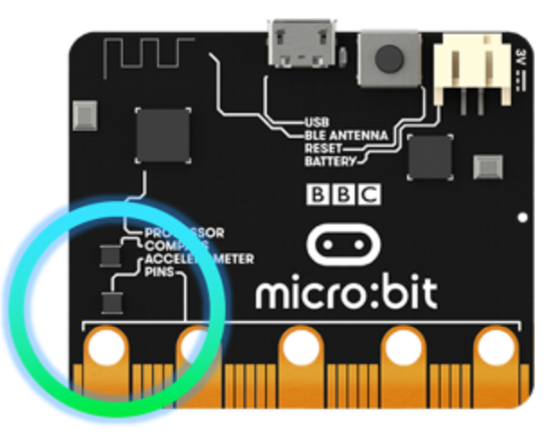
An accelerometer measures the acceleration of your micro:bit; this component senses when the micro:bit is moved. It can also detect other actions, e.g. shake, tilt, and free-fall.
Compass
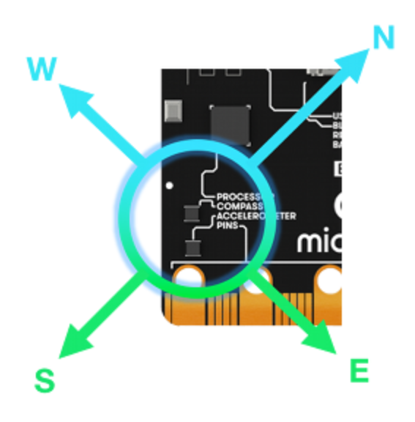
The compass detects the earth's magnetic field, allowing you to detect which direction the micro:bit is facing. The compass has to be calibrated before it can be used.
Radio
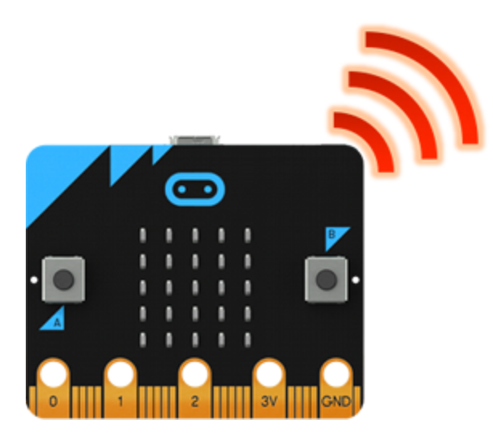
The radio feature allows you to communicate wirelessly between micro:bits. Use the radio to send messages to other micro:bits, build multiplayer games, and much more!

Bluetooth
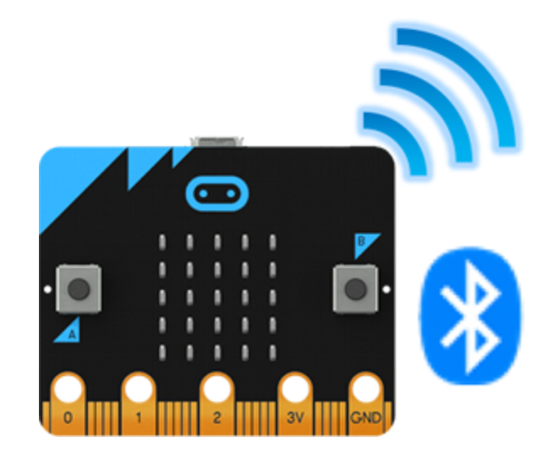
A BLE (Bluetooth Low Energy) antenna allows the micro:bit to send and receive Bluetooth signals. This allows the micro:bit to wirelessly communicate with PCs, Phones, and Tablets, so you can control your phone from your micro:bit and send code wirelessly to your device from your phone!

USB interface
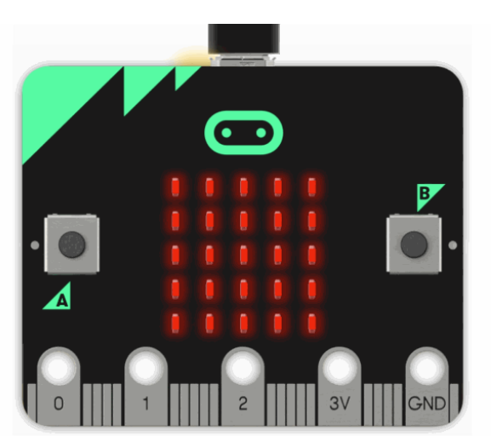
The USB interface allows you to connect the micro:bit to your computer via a micro-USB cable, which will power the device and allow you to download programs onto the micro:bit.

