LEGO MINDSORM JOURNAL
NAME: HOMECLASS:
​​FORWARD/STOP  Student Task: Explore the large motor blocks. A rotation is the distance travelled by one complete wheel rotation. Use the blocks below, explore what they do and see if you can program your robot to go forward and then stop | 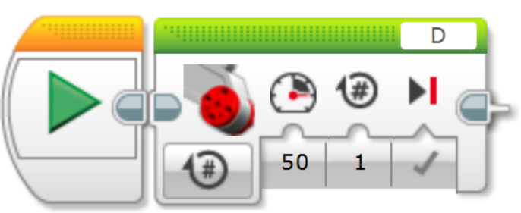  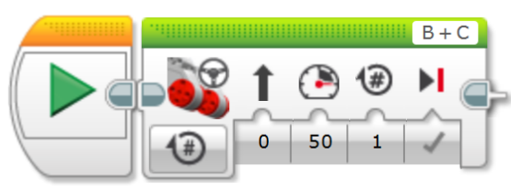
Findings:

​FORWARD/REVERSE  Student Task: Can you work out how to get your robot to move to a line (51 cm in length is a suggestion) and then back again?  Step 1: Place a piece of tape (or use a white board marker line on a desk) as a start line, then mark an end line. Can you program your robot to move and stop on the end line, then go backwards to the start line? | 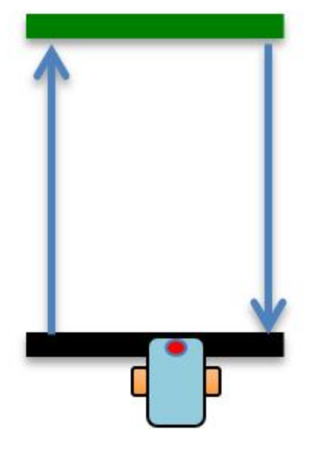
Findings:

SQUARE  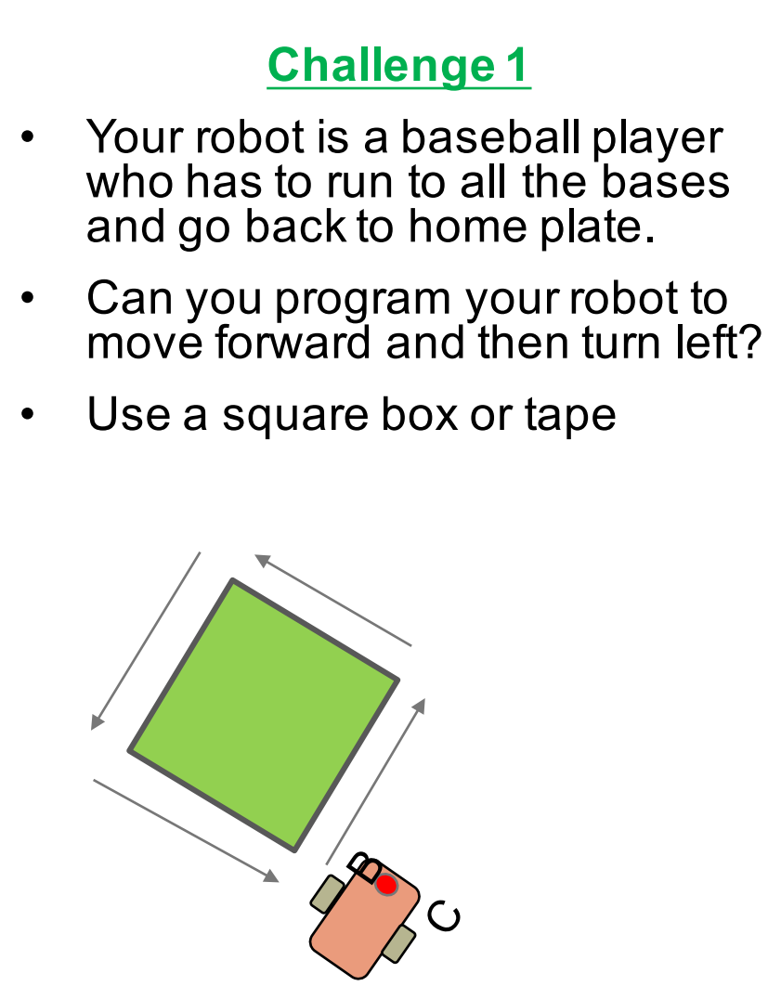 | Record the algorithm you used. Did you use pivot or spin turns?

FORWARD/TURN/RETURN  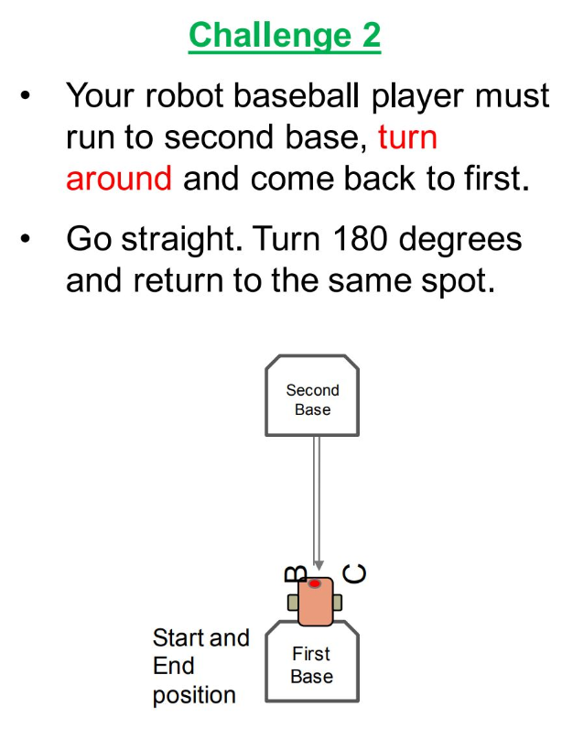 | Record the algorithm you used.

DISPLAY BLOCK CHALLENGE 1: Display ‘Hello World’ on your block and move at the same time
screen capture your algorithm

DISPLAY BLOCK CHALLENGE 2: Display ‘Hello’ on one line and ‘World’ on another line
screen capture your algorithm

DISPLAY BLOCK CHALLENGE 3: Display eyes on the screen whilst moving. Alternate eyeballs that look right and left
screen capture your algorithm

TOUCH SENSOR CHALLENGE 1  Program your robot to move straight until you tap the sensor with your hand. | 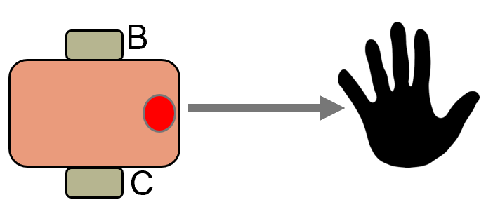
screen capture your algorithm

TOUCH SENSOR CHALLENGE 2  Program your robot to move until it hits the edge of a wall. Then back up and turn right 90 degrees.​ | 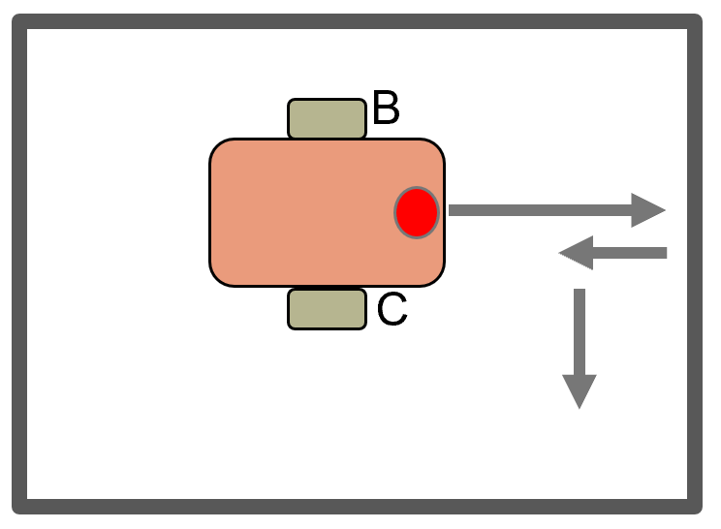
screen capture your algorithm

