DIGITAL TECHNOLOGIES: YEAR 8 LEARNING AND ASSESSMENT PLANS

YEARS 7 AND 8 BAND DESCRIPTION
By the end of Year 8, students will have had opportunities to create a range of digital solutions, such as interactive web applications or programmable multimedia assets or simulations of relationships between objects in the real world.
In Year 7 and 8, students analyse the properties of networked systems and their suitability and use for the transmission of data types. They acquire, analyse, validate and evaluate various types of data, and appreciate the complexities of storing and transmitting that data in digital systems. Students use structured data to model objects and events that shape the communities they actively engage with. They further develop their understanding of the vital role that data plays in their lives, and how the data and related systems define and are limited by technical, environmental, economic and social constraints.
They further develop abstractions by identifying common elements while decomposing apparently different problems and systems to define requirements and recognise that abstractions hide irrelevant details for purposes. When defining problems, students identify the key elements of the problems and the factors and constraints at play. They design increasingly complex algorithms that allow data to be manipulated automatically and explore different ways of showing the relationship between data elements to help computation, such as using pivot tables, graphs and clearly defined mark-up or rules. They progress from designing the user interface to considering user experience factors such as user expertise, accessibility and usability requirements.
They broaden their programming experiences to include general-purpose programming languages, and incorporate subprograms into their solutions. They predict and evaluate their developed and existing solutions, considering time, tasks, data and the safe and sustainable use of information systems, and anticipate any risks associated with the use or adoption of such systems.
Students plan and manage individual and team projects with some autonomy. They consider ways of managing the exchange of ideas, tasks and files, and techniques for monitoring progress and feedback. When communicating and collaborating online, students develop an understanding of different social contexts, for example acknowledging cultural practices and meeting legal obligations.

TOPIC 3: LEGO MINDSTORMS (ROBOTICS)
Design algorithms represented diagrammatically and in English, and trace algorithms to predict output for a given input and to identify errors (ACTDIP029)

Implement and modify programs with user interfaces involving branching, iteration and functions in a general-purpose programming language (ACTDIP030)

ACHIEVEMENT STANDARD
By the end of Year 8, students distinguish between different types of networks and defined purposes. They explain how text, image and audio data can be represented, secured and presented in digital systems.
Students plan and manage digital projects to create interactive information. They define and decompose problems in terms of functional requirements and constraints. Students design user experiences and algorithms incorporating branching and iterations, and test, modify and implement digital solutions. They evaluate information systems and their solutions in terms of meeting needs, innovation and sustainability. They analyse and evaluate data from a range of sources to model and create solutions. They use appropriate protocols when communicating and collaborating online.

GENERAL CAPABILITIES
Literacy | Numeracy | ICT | Critical and Creative Thinking | Personal and Social | Ethical Understanding | Intercultural Understanding
Visual Knowledge  -Understand how visual elements create meaning  Comprehending texts through listening, reading and viewing  -Comprehend texts  -Navigate, read and view learning area texts  -Interpret and analyse learning area texts  Text knowledge  -Use knowledge of text structures  Composing texts through speaking, writing and creating  -Compose spoken, written, visual and multimodal learning area texts  Visual Knowledge  -Understand how visual elements create meaning | Estimating and calculating with whole numbers  -Estimate and calculate  Interpreting statistical information  -Interpret data displays  Recognising and using patterns and relationships  -Recognise and use patterns and relationships  Using spatial reasoning  -Interpret maps and diagrams  - Visualise 2D shapes and 3D objects |  | Analysing, synthesising and evaluating reasoning and procedures  -Apply logic and reasoning  Inquiring – identifying, exploring and organising information and ideas  -Organise and process information  -Identify and clarify information and ideas  Generating ideas, possibilities and actions  -Imagine possibilities and connect ideas  -Consider alternatives  Reflecting on thinking and processes  -Transfer knowledge into new contexts  -Seek solutions and put ideas into action  Reflecting on thinking and processes  -Transfer knowledge into new contexts

CROSS CURRICULUM PRIORITES
Aboriginal and Torres Strait Islander Histories and Culture | Asia and Australia’s Engagement with Asia | Sustainability

TOPIC 3: LEGO MINDSTORMS (ROBOTICS)
BUILDING ROBOTS AND INSTALLING SOFTWARE

Student activity: Teachers guide students through an introduction on how to download the software, how to create projects and programs and the basics of the brick.

Notes for teachers:
1) Go through the user interface (basics)
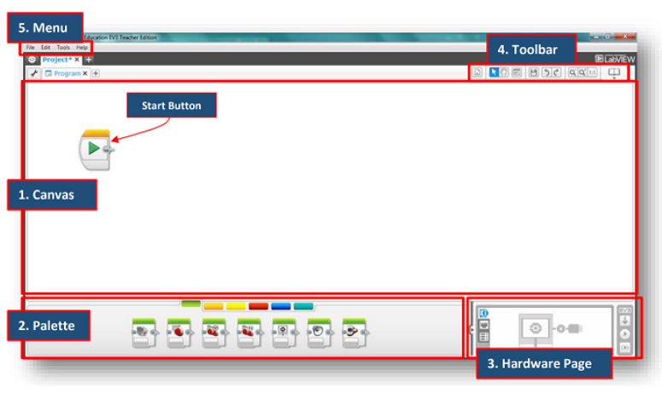
2) Briefly go through the programming pallets, don’t go into detail as students need to explore these during the learning activities.
PDF available for teachers: 1 MTA Programming pallets explained

3) Demonstrate how to connect a robot to a device and how to download a program. Make sure students use the correct ports.
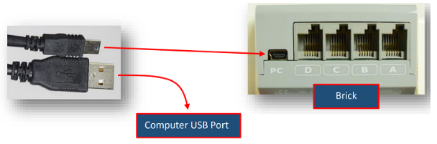
4) Demonstrate how to open and run a downloaded program on the brick.
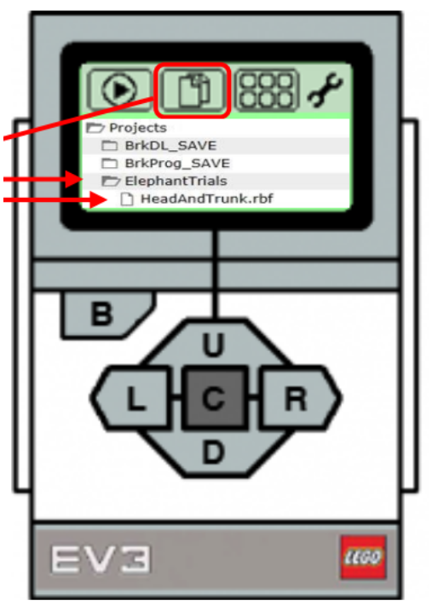
5) Explain how student’s journals will work.
Journal available for teachers: 2 Student Lego Mindstorm Journal

FORWARD/STOP
Student Task: Explore the large motor blocks. A rotation is the distance travelled by one complete wheel rotation. Use the blocks below, explore what they do and see if you can program your robot to go forward and then stop.
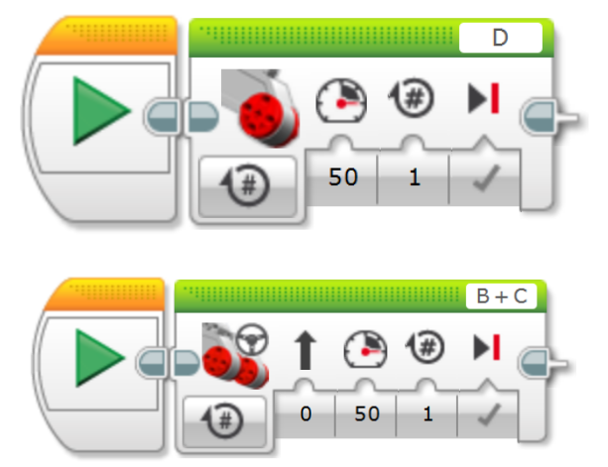
Students record in their journal

FORWARD/REVERSE
Student Task: Can you work out how to get your robot to move to a line (51 cm in length is a suggestion) and then back again? Diagram below, instructions and help guide in the next cell.
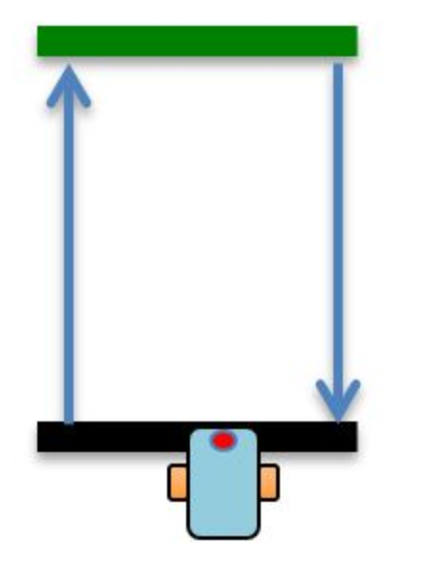
​Step 1: Place a piece of tape (or use a white board marker line on a desk) as a start line, then mark an end line. Can you program your robot to move and stop on the end line, then go backwards to the start line?
Students record in their journal
​​HALF TURN
Student Task: Can you program your robot to complete a 180 degrees turn? What about a 360 degree turn?​​

SQUARE
Student Task: Download and read the document below.
Word doc available for teachers: 3 Basic Turning by Sanjay and Arvind Seshan
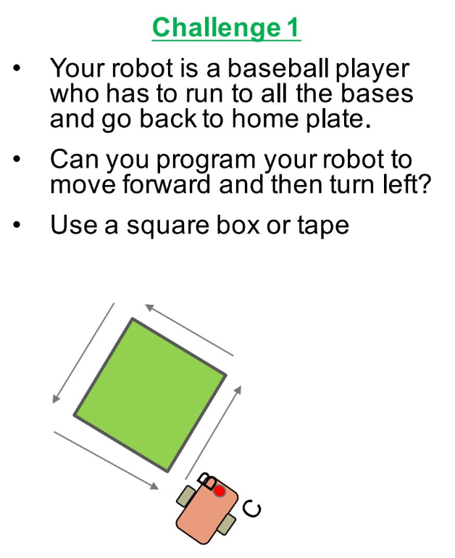
Students record in their journal
FORWARD/TURN/RETURN
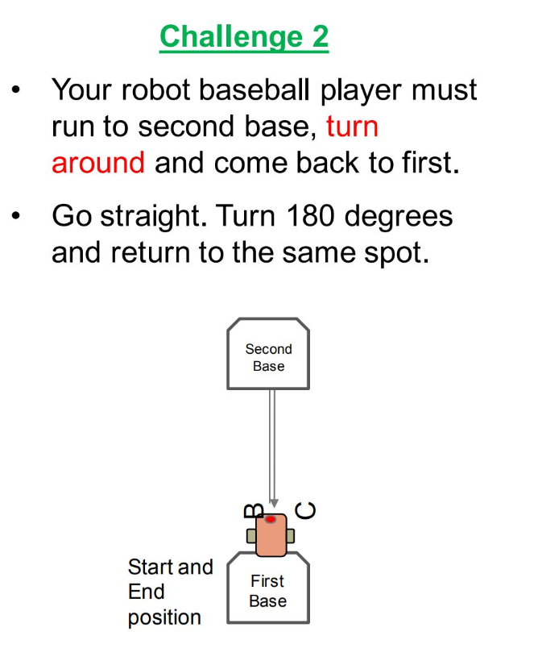
Students record in their journal

DISPLAYING TEXT AND GRAPHICS
Student Task: Download and read the document below.
Word document available for teachers: 4 Displaying Text and Graphics by Sanjay and Arvind Seshan
Display Block Challenge 1: Display 'Hello World' on your block and move at the same time
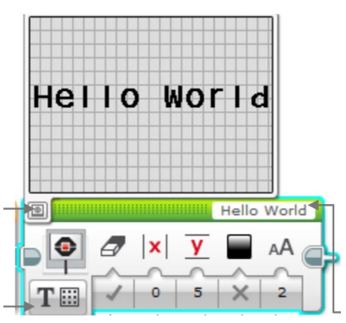
Display Block Challenge 2: Display ‘Hello’ on one line and ‘World’ on another line
Display Block Challenge 3: Display eyes on the screen whilst moving. Alternate eyeballs that look right and left

Students record in their journal
TOUCH SENSOR CHALLENGE 1
Student Task: Download and read the document below.
PPT available for teachers: 5 Touch Sensor by by Sanjay and Arvind Seshan
Challenge 1: Program your robot to move straight until you tap the sensor with your hand.
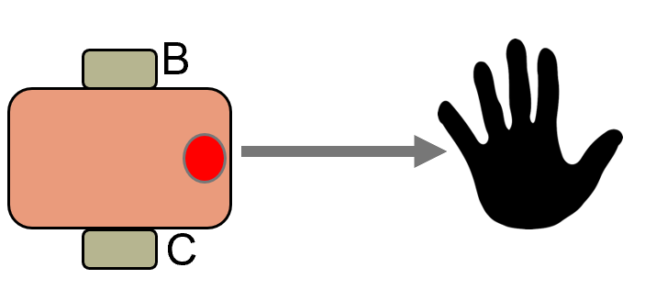
Challenge 2: Program your robot to move until it hits the edge of a wall. Then back up and turn right 90 degrees.​
